Q1

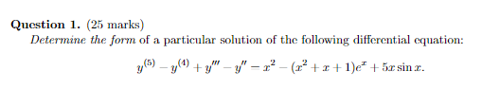

$$y^{\left(5\right)}-y^{\left(4\right)}+y^{'''}-y^{''}=x^{2}-\left(x^{2}+x+1\right)e^{x}+5x\sin\left(x\right)$$

Let

$$\left\{\begin{aligned}L\left[y\right]=y^{\left(5\right)}-y^{\left(4\right)}+y^{'''}-y^{''} \\ g_{1}\left(x\right)=x^{2} \\ g_{2}\left(x\right)=-\left(x^{2}+x+1\right)e^{x} \\ g_{3}\left(x\right)=5x\sin\left(x\right)\end{aligned}\right.$$

CE:

$$r^{5}-r^{4}+r^{3}-r^{2}=0$$

$$↔r^{2}\left(r-1\right)\left(r^{2}+1\right)=0$$

$$↔\left[\begin{aligned}r_{1}=r_{2}=0 \\ r_{3}=1 \\ r_{4}=j \\ r_{5}=-j\end{aligned}\right.$$

We have $g\left(x\right)=g_{1}\left(x\right)+g_{2}\left(x\right)+g_{3}\left(x\right)$, then

+ For $g_{1}\left(x\right)=x^{2}$, with $α=0≡r_{1}≡r_{2}$ is double root of CE

+ For $g_{2}\left(x\right)=-\left(x^{2}+x+1\right)e^{x}$, with $α=1≡r_{3}$ is single root of CE

+ For $g_{3}\left(x\right)=5x\sin\left(x\right)$, with $α+jβ=0+j=j≡r_{4}$ is single root of CE

$$y_{P3}=\left[\left(Gx+H\right)\sin\left(x\right)+\left(Ix+J\right)\cos\left(x\right)\right]⋅x$$

Thus,

$$y_{P}=y_{P1}+y_{P2}+y_{P3}$$

$$=\left(Ax^{2}+Bx+C\right)x^{2}+\left(Dx^{2}+Ex+F\right)e^{x}x+\left[\left(Gx+H\right)\sin\left(x\right)+\left(Ix+J\right)\cos\left(x\right)\right]x$$

Q2)

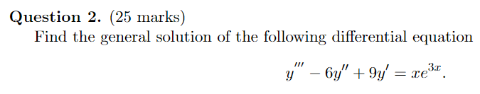

$$y^{'''}-6y^{''}+9y'=xe^{3x}$$

$$\left\{\begin{matrix}L\left[y\right]=y^{'''}-6y^{''}+9y' \\ g\left(x\right)=xe^{3x}\end{matrix}\right.$$

CE:

$$r^{3}-6r^{2}+9=0$$

$$↔r{\left(r-3\right)}^{2}=0$$

$$↔\left\{\begin{aligned}r_{1}=0 \\ r_{2}=r_{3}=3\end{aligned}\right.$$

Therefore, the complement solution is

$$y_{C}=C_{1}+C_{2}e^{3x}+C_{3}xe^{3x}$$

For $g\left(x\right)=xe^{3x}$, with $α=3$ is double root of CE

$$y_{P}=\left(Ax+B\right)e^{3x}⋅x^{2}=\left(Ax^{3}+Bx^{2}\right)e^{3x}$$

$$→y_{P}^{'}=\left(3Ax^{3}+\left(3A+3B\right)x^{2}+2Bx\right)e^{3x}$$

$$→y_{P}^{''}=\left(9Ax^{3}+\left(18A+9B\right)x^{2}+\left(6A+12B\right)x+2B\right)e^{3x}$$

$$→y_{P}^{'''}=\left(27Ax^{3}+\left(81A+27B\right)x^{2}+\left(54A+54B\right)x+18B+6A\right)e^{3x}$$

Substitute $y_{P}$ into $L\left[y_{P}\right]=g\left(x\right)$, we obtain

$$\left(18Ax+6A+6B\right)e^{3x}=xe^{3x}$$

$$↔18Ax+6A+6B=x$$

$$→\left\{\begin{aligned}18A=1 \\ 6A+6B=0\end{aligned}\right.→\left\{\begin{aligned}A=\frac{1}{18} \\ B=-\frac{1}{18}\end{aligned}\right.$$

Therefore,

$$y_{P}=\left(\frac{1}{18}x^{3}-\frac{1}{18}x^{2}\right)e^{3x}$$

Thus,

$$y_{G}=y_{C}+y_{P}=C_{1}+C_{2}e^{3x}+C_{3}xe^{3x}+\left(\frac{1}{18}x^{3}-\frac{1}{18}x^{2}\right)e^{3x}$$

Q3)

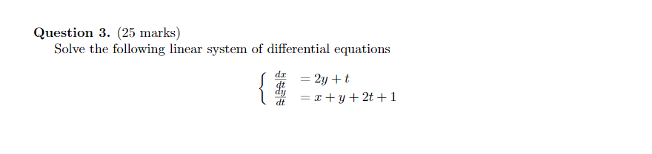

$$\left\{\begin{aligned}x^{'}=2y+t, (1) \\ y^{'}=x+y+2t+1, (2)\end{aligned}\right.$$

Differentiating both sides with respect to $t$ of equation $(1)$, we get

$$x^{''}=2y^{'}+1 \left(3\right)$$

Taking $2×\left(2\right)-1×(1)$, we obtain

$$2y^{'}-x^{'}=2×x+2×y-2y+2×\left(2t+1\right)-t=2x+3t+2$$

$$2y^{'}=x^{'}+2x+3t+2 \left(4\right)$$

Substituting $\left(4\right)$ into $\left(3\right)$, it leads to

$$x^{''}=\left(x^{'}+2x+3t+2\right)+1$$

$$↔x^{''}-x^{'}-2x=3t+3 \left(*\right)$$

This is second order non-homogeneous differential equation

$$x\left(t\right)=x_{C}\left(t\right)+x_{P}(t)$$

CE:

$$r^{2}-r-2=0↔\left[\begin{aligned}r_{1}=-1 \\ r_{2}=2\end{aligned}\right.$$

$$→x_{C}\left(t\right)=C_{1}e^{-t}+C_{2}e^{2t}$$

We have $g\left(t\right)=3t+3$ with $α=0≠r_{1},r_{2}$ is not a root of CE, therefore

$$x_{P}=At+B→x_{P}^{'}=A→x_{P}^{''}=0$$

Substitute $x_{P}$ into $\left(*\right)$ yields

$$0-A-2\left(At+B\right)=3t+3$$

$$↔-2At-A-2B=3t+3$$

$$→\left\{\begin{aligned}-2A=3 \\ -A-2B=3\end{aligned}\right.↔\left\{\begin{aligned}A=-\frac{3}{2} \\ B=-\frac{3}{4}\end{aligned}\right.$$

Hence

$$x_{P}\left(t\right)=-\frac{3}{2}t-\frac{3}{4}$$

Thus,

$$x\left(t\right)=x_{C}\left(t\right)+x_{P}\left(t\right)=C_{1}e^{-t}+C_{2}e^{2t}-\frac{3}{2}t-\frac{3}{4}$$

Then

$$x^{'}\left(t\right)=-C_{1}e^{-t}+2C_{2}e^{2t}-\frac{3}{2}$$

From $\left(1\right)$:

$$x^{'}=2y+t$$

$$↔y=\frac{1}{2}\left(x^{'}-t\right)=\frac{1}{2}\left(-C_{1}e^{-t}+2C_{2}e^{2t}-\frac{3}{2}-t\right)$$

$$=-\frac{1}{2}e^{-t}+C_{2}e^{2t}-\frac{1}{2}t-\frac{3}{4}$$

Thus

$$\left\{\begin{aligned}x\left(t\right)=C_{1}e^{-t}+C_{2}e^{2t}-\frac{3}{2}t-\frac{3}{4} \\ y\left(t\right)=-\frac{1}{2}e^{-t}+C_{2}e^{2t}-\frac{1}{2}t-\frac{3}{4}\end{aligned}\right.$$

Q4)

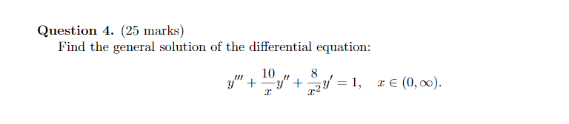

$$y^{'''}+\frac{10}{x}y^{''}+\frac{8}{x^{2}}y'=1 \left(*\right)$$

First we have to find complement solutions of $\left(*\right)$ which are solution of the homogenous equation

$$y^{'''}+\frac{10}{x}y^{''}+\frac{8}{x^{2}}y'=0 (1)$$

Assume that $y=x^{α}$ is a solution of $\left(1\right)$.

$$→y^{'}=αx^{α-1};→y^{''}=α\left(α-1\right)x^{α-2}→y^{'''}=α\left(α-1\right)\left(α-2\right)x^{α-3}$$

Substitute $y$ into $\left(1\right)$, we get

$$α\left(α-1\right)\left(α-2\right)x^{α-3}+10\frac{α\left(α-1\right)x^{α-2}}{x}+8\frac{αx^{α-1}}{x^{2}} =0$$

$$↔α\left(α-1\right)\left(α-2\right)+10α\left(α-1\right)+8α=0$$

$$↔α\left(α^{2}+7α\right)=0$$

$$↔\left[\begin{aligned}α_{1}=0 \\ α_{2}=0 \\ α_{3}=-7\end{aligned}\right.→\left[\begin{aligned}y_{1}=1 \\ y_{2}= -7\end{aligned}\right.$$

Assume that $y=x^{α}\ln\left(x\right)$ is a solution of $\left(1\right)$.

$$→y^{'}=\frac{x^{α}}{x}+α\left(α-1\right)x^{α-1}\ln\left(x\right);$$

$$→y^{''}=\frac{{2αx}^{α-1}}{x}-\frac{x^{α}}{x^{2}}+α\left(α-1\right)\left(α-2\right)x^{α-2}\ln\left(x\right)$$

$$→y^{'''}=\frac{{2x}^{α}}{x^{3}}-\frac{{3αx}^{α-1}}{x^{2}}+\frac{{3α(α-1)x}^{α-2}}{x}+α\left(α-1\right)\left(α-2\right)\left(α-3\right)x^{α-2}\ln\left(x\right)$$

Substitute $y$ into $\left(1\right)$, we get

$$α x^{α-3}\left(3α+7α\ln\left(x\right)+α^{2}\ln\left(x\right)+14\right)=0$$

Since, with $α=0$, is a solution of above equation, so

$$y=x^{0}\ln\left(x\right)=\ln\left(x\right)$$

Let $y_{3}=y=\ln\left(x\right)$

Since, $y_{1}, y_{2}, y_{3}$ are solutions of $\left(1\right)$ and satisfy Wronskian determinant different from zero for $x>0$.

Therefore,

$$y_{C}=C_{1}y_{1}+C_{2}y_{2}+C_{3}y_{3}=C_{1}+C_{2}x^{-7}+C_{3}\ln\left(x\right)$$

Find particular solution:

$$y^{'''}+\frac{10}{x}y^{''}+\frac{8}{x^{2}}y^{'}=1$$

By variation of parameters, we have

$$y_{P}=u_{1}\left(x\right)y_{1}+u_{2}\left(x\right)y_{2}+u_{3}\left(x\right)y_{3}=u_{1}\left(x\right)+u_{2}\left(x\right)x^{-7}+u_{3}\left(x\right)\ln\left(x\right)$$

To find $u_{1}\left(x\right), u_{2}\left(x\right),$ and $u_{3}\left(x\right)$, we have to solve the following system of equations

$$\left\{\begin{aligned}u_{1}^{'}+u_{2}^{'}x^{-7}+u_{3}^{'}\ln\left(x\right)=0, (a) \\ 0+u_{2}^{'}\left(-7x^{-8}\right)+u_{3}^{'}\left(\frac{1}{x}\right)=0, (b) \\ 0+u_{2}^{'}\left(56x^{-9}\right)+u_{3}^{'}\left(-\frac{1}{x^{2}}\right)=1, (c)\end{aligned}\right.$$

Let $x×\left(c\right)+\left(b\right)$:

$$u_{2}^{'}\left(49x^{-8}\right)=x→u_{2}^{'}=\frac{x^{9}}{49}→u_{2}=\frac{x^{10}}{490}$$

Form $\left(b\right)$:

$$u_{3}^{'}=u_{2}^{'}\left(7x^{-8}\right)=\frac{x}{7}→u_{3}=\frac{x^{2}}{14}$$

Form $\left(a\right)$:

$$u_{1}^{'}=-u_{2}^{'}x^{-7}-u_{3}^{'}\ln\left(x\right)=-\frac{x^{2}}{49}-\frac{x}{7}\ln\left(x\right)→u_{1}=-\frac{x^{3}}{147}-\frac{1}{14}x^{2}\ln\left(x\right)+\frac{1}{4}x^{2}$$

So,

$$y_{P}=-\frac{x^{3}}{147}-\frac{1}{14}x^{2}\ln\left(x\right)+\frac{1}{4}x^{2}+\frac{x^{10}}{490}x^{-7}+\frac{x^{2}}{14}\ln\left(x\right)=-\frac{x^{3}}{210}+\frac{1}{4}x^{2}$$